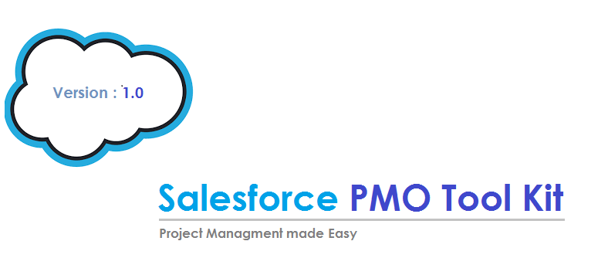

Release Date: 12th April 2017

Overview
What is PMO?
A project management office, abbreviated as PMO, is a group or department within a business, agency or enterprise that defines and maintains standards for project management within the organization. The PMO strives to standardize and introduce economies of repetition in the execution of projects. The PMO is the source of documentation, guidance and metrics on the practice of project management and execution.
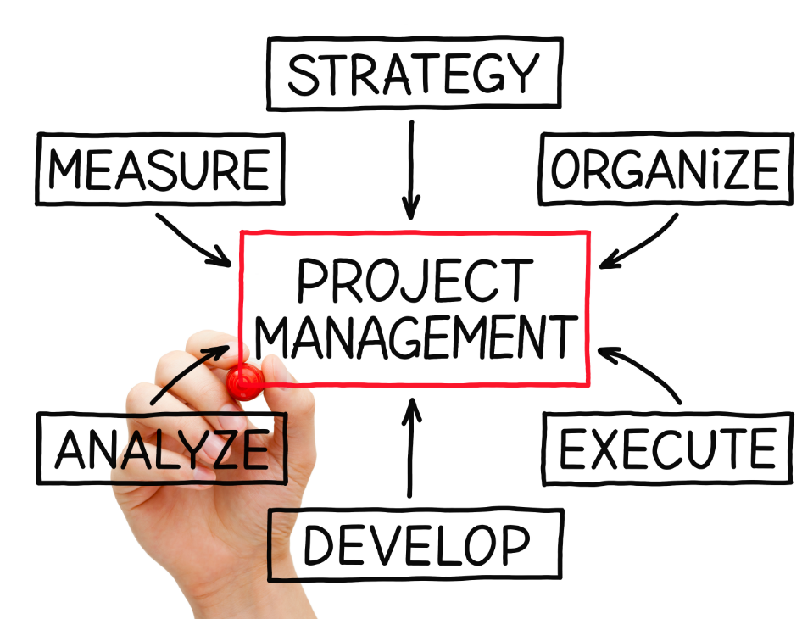
And what about the tool Kit?
Project management tool Kit has the capacity to help plan, organize, and manage resource and develop resource estimates for any of your projects. Depending on the sophistication of the software, it can manage estimation and planning, perform resource management, communication and many other notable things, which helps to execute your projects in a more efficient way and achieve the targeted
But why should we have PMO tool in Salesforce ? 
With the PMO toolkit built in Saleseforce, it’s just a matter of some clicks to configure the tool according to your own business need. PMO Salesforce tool kit is a generic toll which suits, managing all types of project as per the business requirement. Salesforce being on cloud, there is no overhead of server, database and manage network protocols to access the data. PMO toolkit on Saleforce is the most efficient way to manage your projects.
In consideration to the IT & Business Services, this PMO is designed which covers the various aspects of the Projects. It covers the different entities which are involved in project like Releases, Sprints, Requirements, User Stories, Defects, and Project Team etc.
With this PMO toolkit, the different process which are executed in a project are automated and streamlined and helps in the ease of the execution of the project.

Data Model of PMO Tool Kit

Projects
Requirements
Release
User Stories
Defects
Question & Answers
Test Suite
Sprints
Data Model Definition
- Projects: The project entity will contains all the details of a project related to a specified customer. Such as Project duration, Budget Information, Description , Project owner (Contact Person for the Project) etc.
A Project will have multiple requirements associated with it. Also Projects will have multiple sprints and releases for efficient project execution. (More Information on Sprints and Release will be discussed later in the document) Resources allocated or working on a project can also be viewed and edited from the same page of the application. Below is the representation of the same.
- Project Details Snap Shot
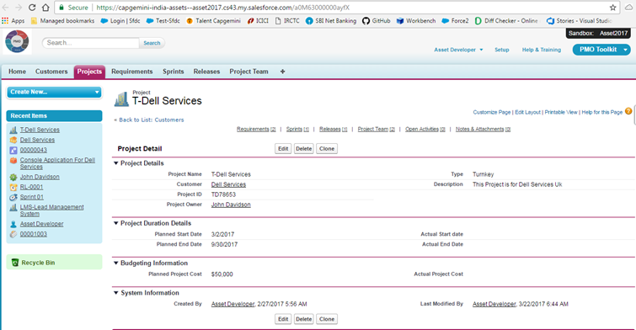

- Related details for a Project Snap Shot (Requirements, Sprints, Release)
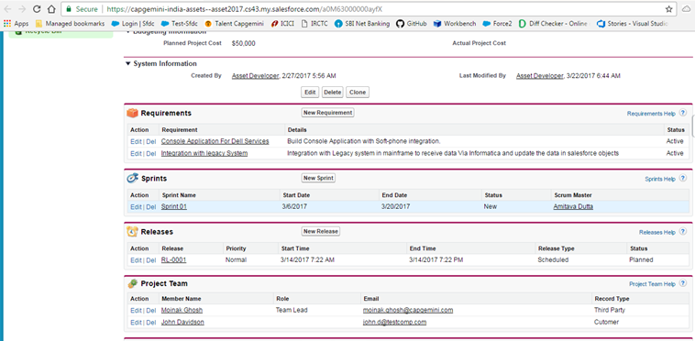
- Sprints: The entire time period for a project execution is sub-divided into smaller time frames for efficient management and development of the business requirements. A specific timeline is provided for the completion of each sprint which does have multiple requirements associated with it. The requirements which are related to a particular Sprint are available as a related list. Each sprint does have a Scrum Master who is single point of contact for the same. Status regarding a sprint execution is usually maintained by the scrum master.

- Sprints Snap Shot
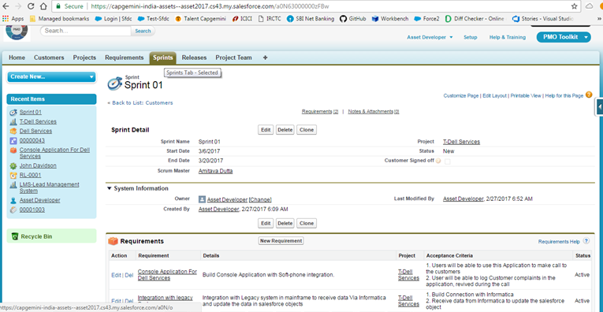

- Requirements: The requirements entity under a Project will contain the details of business need and the acceptance criteria to establish the successful execution of the same. Requirements will be further subdivided into user story for an efficient and better approach towards the development of the requirement. Form the requirement page of the application we can Add, View and edit the related User stories.
Technically Requirements does have a master detail relationship with the user stories object/entity. Planned effort and Actual effort of the requirement will get automatically calculated (Via Roll up summary field) from the related user stories.

- Requirement Snap Shot
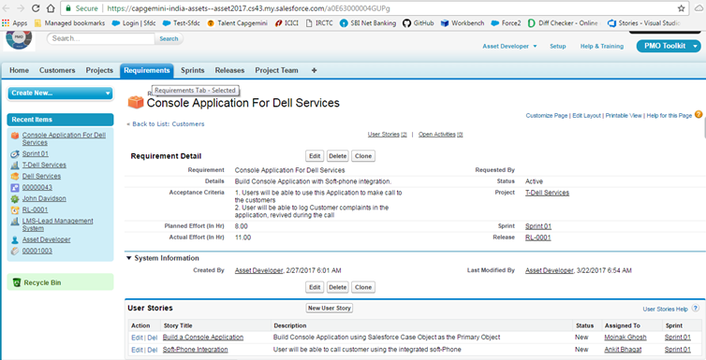

- User Stories & Defects: user stories can be described as a sub division of a requirement. User stories entity/object does contain the information to develop and test a portion of a business requirement. It contains information regarding the estimated and the actual effort details at a granular level. Details regarding a resource allocated for development of a user story are also present. An email alert gets generated for the Assigned resource when he/she has been assigned to work on the user story.
- Defects (commonly known as bugs) are issues that are recorded during the functionality test, once the user story has been developed. Multiple Defects can be raised for a particular user story and can be assigned to a project resource to work on.

- User story Snap Shot
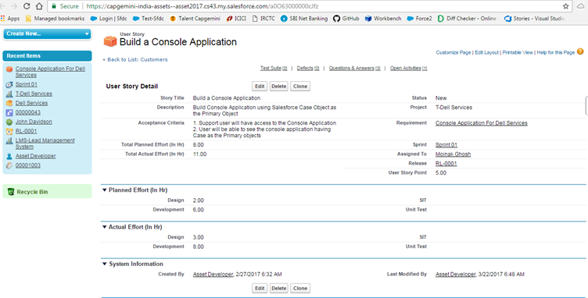

- Test suites are the test scenarios that a requirement of a user story needs to be passed for a successful completion of the user story. The test scenario description, along with the expected results is mentioned in the details of a test suite. A tester needs to update the test suite with the actual test results once the testing is complete for the related user story. There can be multiple test suites associated with a user story. Once any of the test scenarios gets failed, a defect can be recorded for the same user story.

- Test Suites Snap Shot
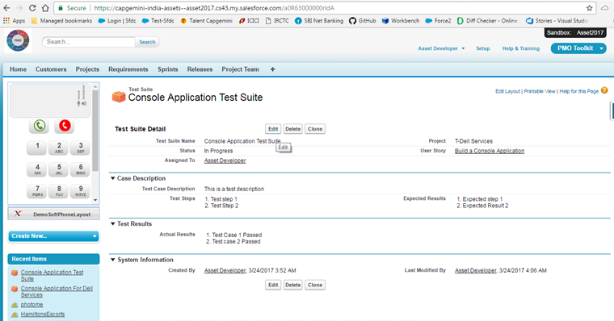

- Question and Answer: Any query related to a user story can be recorded in the question and answer section of the same user story. Questions are posted and are assigned to a particular project resource to have the query resolved. The assigned to resource is responsible to provide resolution to the posted query and have it resolved. An Email alert gets generated for the assigned to resource when a question is posted similarly when the query has been answered an email alert gets generated for the user who posted the query. (Note: To have the Email alert generated the Status field needs to be updated accordingly)

- Question and Answer Snap Shot
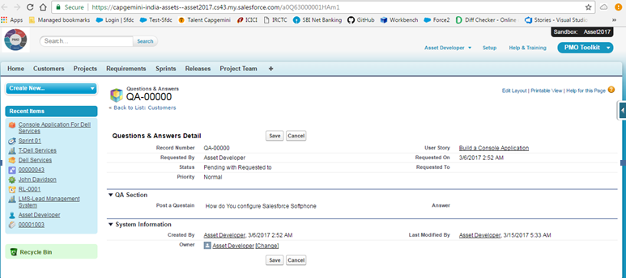

- Release: Finally, once the entire user stories related to a sprint gets completed; they are clubbed and put under a single release record to complete the roll out for Production environment. A release record has multiple user sorties associated with it that are intended to be rolled out to the production. Release record contain details regarding the release time frame (Time Window for the release), Release owner (Single point of contact for any queries regarding the release).
Before the roll out process, Release Owner needs to approve the release record to proceed with the release process. The user of the application (who have created the release record) , need to submit it for approval to the Release owner for approval.

- Release Snap Shot
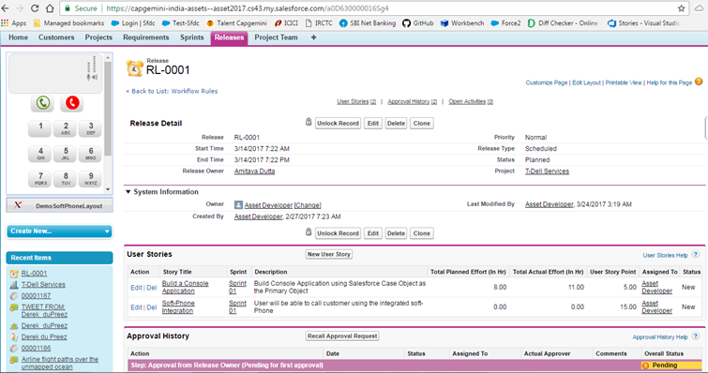

- PMO Dashboards:
The PMO Dashboard contains Graphical representation of certain reports generated from the application. The Reports are very much configurable and can be easily modified as per the business requirement.

- Dashboards Snap Shot
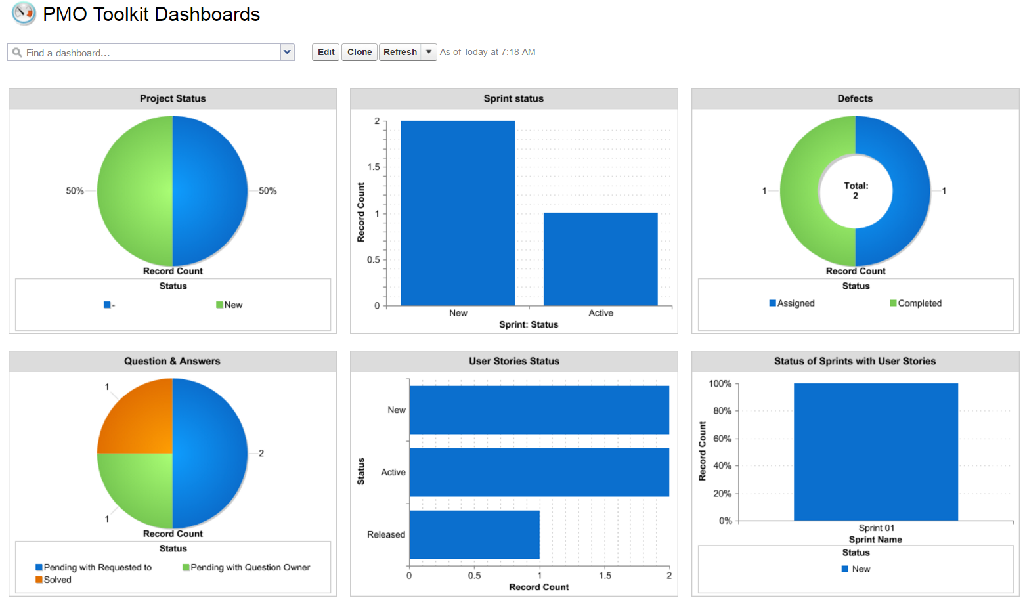

So, start using the PMO toolkit on the cloud for efficient handling of the projects and to provide your organization the freedom to scale the application as per the business need, with just some simple clicks.
Let the force be with You…

